**ENGINEER ASTRA**

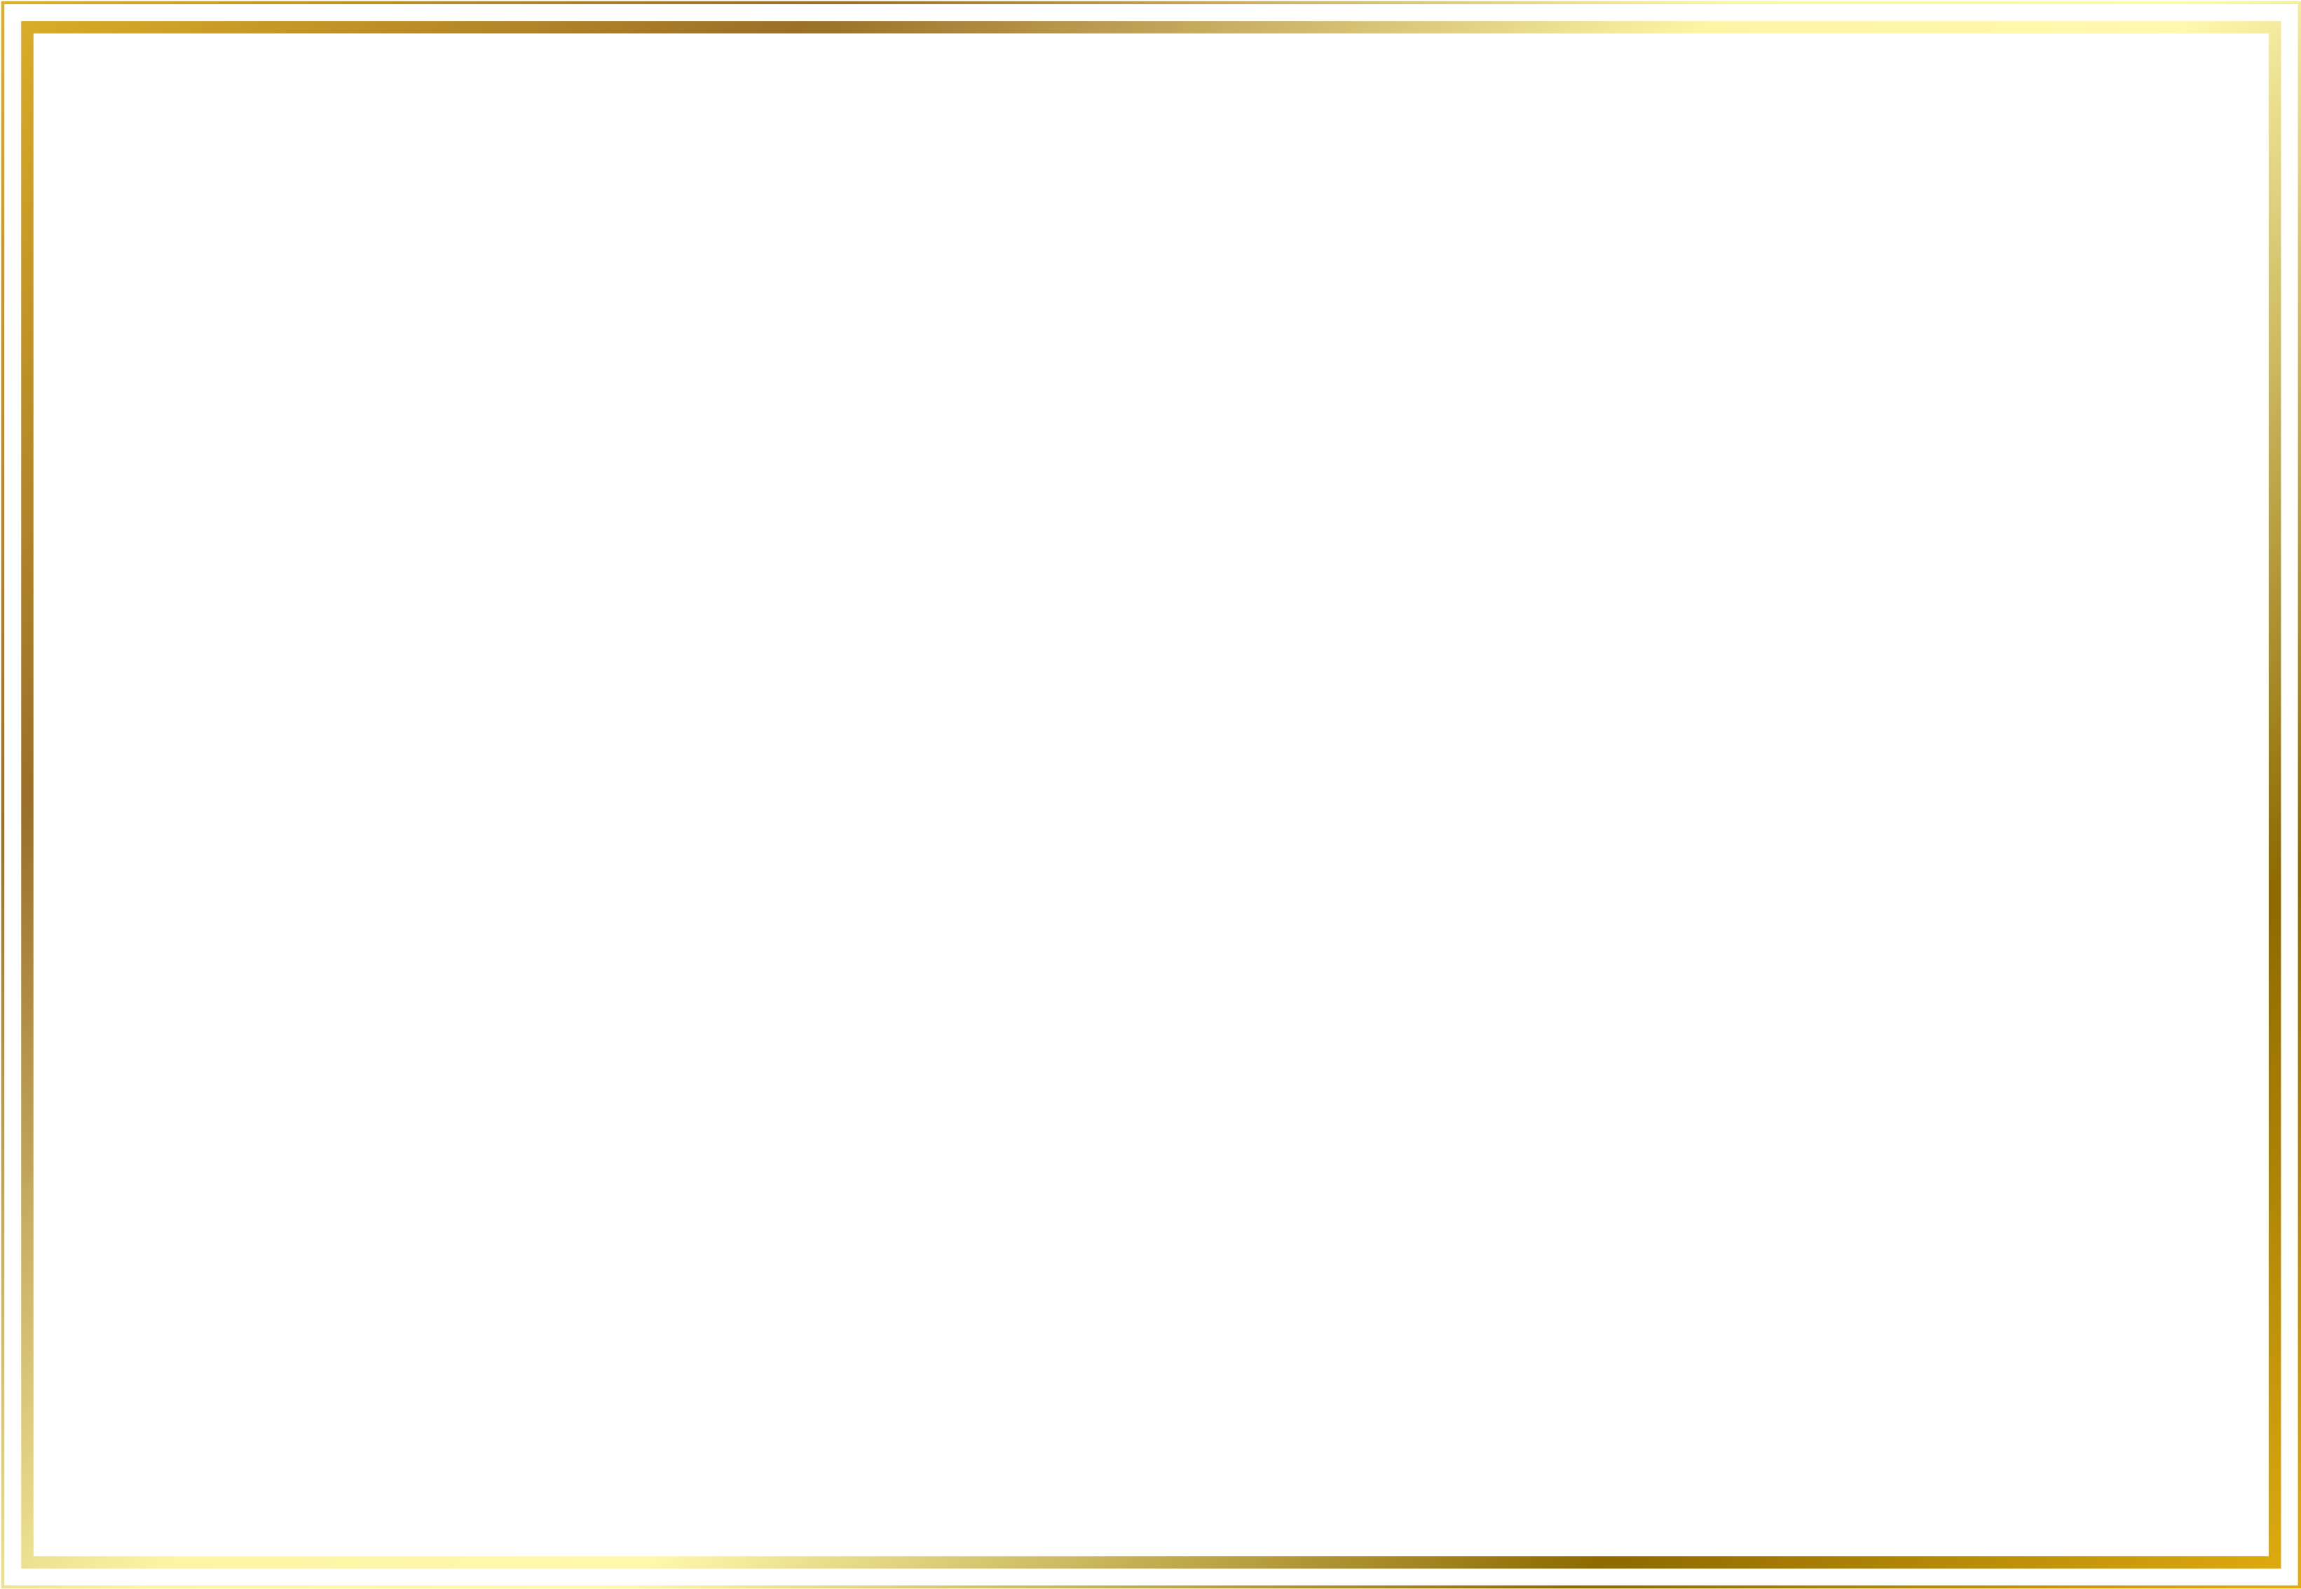

**CERTIFICATE**

THIS CERTIFICATE IS PROUDLY PRESENTED TO

**OF APPRECIATION**

{{name}}

Who has successfully completed the {{course}} course on {{date}}

**Vishal Tiwari**

Founder, Engineer Astra



{{date}}